**FOOD PROCESSORS (FIJI) LTD**

**Batiri Farm – Agricultural Land – Investment Opportunity**



**Batiri Farm** is a Native lease property located at Lot 1, 2, 3 Vunivere Road, Batiri, Vanua Levu, Fiji Islands. The Property lease title is held by Food Processors (FIJI) LTD.

The farm is venturing into joint venture or leasing of the farm property to potential investors in agriculture sector.



**Location & Land Detail**

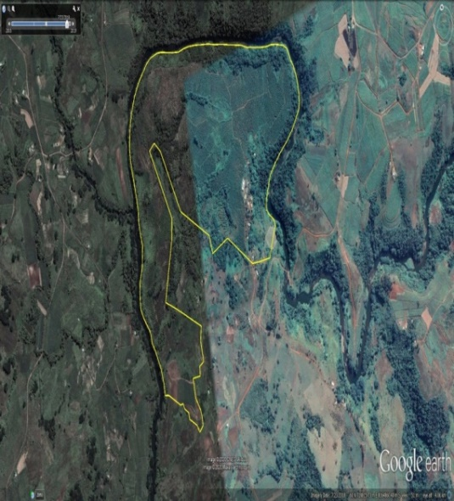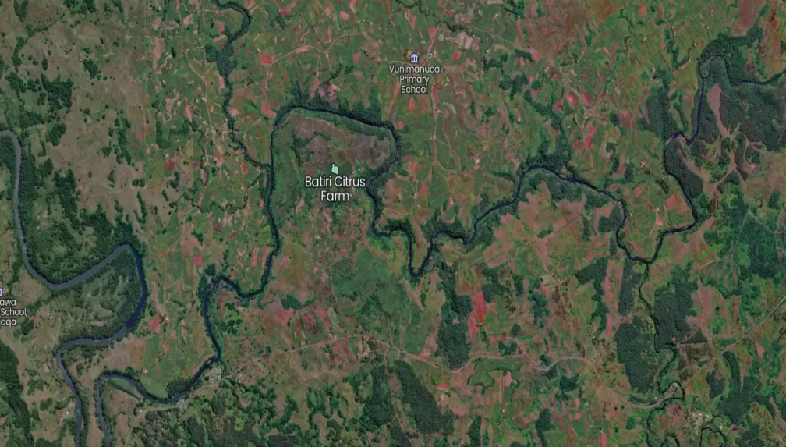

Coordinates- xx

<https://mapcarta.com/35535698/Map>

|  |  |  |  |  |  |
| --- | --- | --- | --- | --- | --- |
| **Property** | **Type** | **Property #** | **Acre** | **Term** | **Lease Ref** |
| Agriculture - Batiri - Citrus | Native | Lot 1 CD 389 | 377 acres | 30 years | 15/13792 |
| Industrial Property | Native | Lot 2 CD 389 | 2.912 acres | 99 years | 15/13678 |
| Residential Property | Native | Lot 3 CD 389 | 8.362 acres | 99 years | 99/10220 |
| Agriculture Property | Agriculture Land | TLTB :4/9/38875 | 39.346 acre | 30 years | 9/38875 |
|  |  |  | **427.734** |  |  |

 **Opportunities**

* Large built warehouse with potential to be used for processing site
* Staff office with potential to work on site
* 6 meter deep reservoir with potential for water storage in dry spell
* 2x Large English Villa with potential to be used for staff occupancy
* 4 x staff quarter with potential to be either renovated for occupancy or used as storage
* Nearby free flowing Dreketi river
* 110 acre - 10,000 Orange Trees – Famous Batiri Oranges
* 40 acre sugar cane farm
* 5 acre vegetable farm
* 277 acre - Large land area for further cultivation and improvement

** Economic Indicators in Support of Volume**

The following indicators allows for growth opportunity:

* Government “Look North Policy “allows for opportunity to investors to grow in the Vanua Levu.
* With COVID- 19 Pandemic becoming a reality check factor on sustainability of any economy ,

agriculture sector growth and support is a crucial factor for maintaining Food Security

* With abundance of resources available in Vanua Levu, it can be ideal opportunity for investors to value add.

**Required Investment - Batiri Farm**

|  |  |  |  |
| --- | --- | --- | --- |
|  | **Capital Projects** | **Purpose** | **Estimate Value** |
| 1 | **Tractor & Implements** | For purpose of Farm function and currently no mechanical tool to optimize farm operation | **150,000.00** |
| 2 | **Off roader - 4x 4** | To manage logistics at farm and reduce hiring cost | **86,000.00** |
| 3 | **Freezer Truck - 3 ton** | Transportation of raw material and delivery and reduce hiring cost | **120,000.00** |
| 4 | **New Batiri Orchard Setup** | For future growth and replace 40 year old trees. New orange trees will ensure farm sustainability in future and promote production of local oranges | **77,100.00** |
| 5 | **Electricity set up** | Currently no power supply to farm warehouse and for semi processing  setup 3 phase power would be needed | **250,000.00** |
| 6 | **Solar Farm** | * Potential for bare land to be converted to large solar power farm * Investor to provide per care investment value and power generation capacity | |
| **683,100.00** | | | |